To: |  |  |  | Shareholder and Joint Venture Group
Date: |  |  |  | Wednesday 1st November 2023
Report of: |  |  |  | Sarah Knight, Head of Development
Title of Report: |  |  |  | Quarterly Progress Report relating to Barton Oxford LLP
 | Summary and recommendations
 | Purpose of report: |  | This report provides an update into the activities of Barton Oxford LLP (BOLLP) over the past quarter.
Recommendation(s):
There is a resolution to:
- Approve the appointment of Deloitte as the external auditors as detailed in paragraph 5
- Note the contents of the report

Appendices
- None

Introduction and background
- This is the sixteenth report to the Shareholder and Joint Venture Group covering the period since the previous update in June 2023.
- In terms of wider market context, national house prices have fallen over the last 12 months but at rates less than originally anticipated. Higher interest rates are putting pressure on buyers’ budgets but the recent unchanged interest rate and inflation continuing to fall in line with expectations does provide some comfort. Anecdotally agents report that the Oxford market continues to show resilience and, in the summer, Oxford house prices performed better than the average for the south east.
- On site delivery at Barton Park continues with two active phases – phase 3 with Redrow and phases 2 and 4 with Vistry/Countryside. Some on-site delays have been reported. These delays seem to be a result of both Redrow and Vistry having internal changes (the merger in the case of Vistry and the closing of a regional office in the case of Redrow) which has slowed activity. Responding to changes in personnel and establishing new key contacts at the housebuilders to monitor progress on site is key for the LLPs project group and is ongoing.
- Other remaining activities for the LLP are the sale of phase 3B; finalising any necessary agreements emerging from the development of land north of Bayswater Brook; and concluding the obligations emerging from the previous sale of parcels and the wider estate infrastructure. The LLP will also have to set up the legacy Management Company once the scheme is nearing completion.

Approval for the appointment of new external auditors
- The audit arrangements for the LLP are managed by Grosvenor with the appointment of Auditors being a matter reserved for Members. The Members’ Representatives have considered the advice of the Grosvenor Finance Team who are looking to engage Deloitte for the 2024 audit. This would be a change from Mazars based on achieving value for money and a good service. Representatives have also discussed this proposal with Oxford City Council’s Finance Team. The change to auditors is proposed after the 2023 accounts are signed which is anticipated to be by the end of October. Members are asked to note this update and approve the appointment of Deloitte as Auditors for the LLP.

Progress Update on individual estates and estate-wide infrastructure
- As previously reported, the first phase (developer: Hill) of 237 homes with 95 affordable is now completed with no significant issues to report.
- The second phase (developer: Redrow) is to deliver 207 homes in total of which 83 are affordable. At the start of October 2023, Redrow had reported 120 completions – 48 affordable and 72 private sales. Based on the affordable housing programme, delivery has slipped by about 3 months over the last year. Redrow’s final completion is current due in quarter 1 of 2025.

- The third phase (developer: Countryside, now Vistry) is for 434 homes. This phase includes 174 S106 affordable homes; 96 “additional” affordable homes being sold to Places for People; and the retail element. Vistry are now expecting their show home to complete in the first quarter of 2024 with occupations from quarter two of 2024. Vistry have reported delays on site of six months from their programme in January of this year. Their final completions are currently programmed for 2027.

- Delays in completion do have an impact on the LLP in the context of the payments under the Section 106 agreements which are index-linked for inflation. This is being monitored by the LLP. The developers’ delaying delivery also has an impact on the speed at which affordable homes are delivered. Officers at the Council and the Housing Company continue to keep this under review.

- After some significant delays with Oxfordshire County Council, the Section 278 Agreement (the legal agreement with Oxfordshire County Council which will see them adopting the junction with the A40) should be in place shortly. The completion of the Section 38 agreement (an agreement with Oxfordshire County Council for them to take ownership of the roads) for the adoption of phase 1 of the highways is dependent on the S278 adoption and therefore is imminent. The S38 agreement for phase 2 of the road is progressing but dependent on the removal of the temporary bus turning which is estimated to be in 2024. Until this point, the LLP will remain liable for this phase of the road.

Sale of Barton 3B
- Since the last Shareholder and Joint Venture Group, we have unfortunately lost the prospective buyer of Barton 3B. This is primarily due to a change in their business plan and appetite for schemes. The delay that has been caused by trying to regularise the planning position on Barton 3B has also contributed to this.

- From a planning perspective, the outline consent granted permission for 885 residential units at Barton Park. 878 of these homes are now consented under the reserved matters consent for phases 1, 2, 3 and 4 (Hill, Redrow and Vistry phases). It had been envisaged that Barton 3B (the last remaining parcel of land) would be submitted as a new full application since the site can deliver more than the balance of 7 homes.

- As reported at the last Shareholder and Joint Venture Group, the “Hillside Case” has created a potential planning risk in proceeding on this basis. In essence, the overlapping of red line of the outline permission with another planning application (ie an application for Barton 3B) may restrict implementation of other areas of the permission currently being built out if enforced against by the LPA. The Hillside case approved a principle that where Permission A is granted for development of a whole site (the original permission) and Permission B (the “drop in” permission) is subsequently granted and implemented within the same red line boundary, it can become “physically impossible” to comply with Permission A. In that situation, a developer can no longer rely on Permission A to build out any further development under Permission A. For Barton 3B, advice to the LLP has been that there is a low risk of this “physical impossibility” occurring but the impact if it did would be high. Specifically, it would risk the covenants granted by the LLP to the other developers in the sale of the land to ensure that the outline permission remains available to them.

- In response to this, the LLP are currently exploring three options
  - Market for sale with 7 plots (as a reserved matters under the outline consent). An updated valuation is being sought on this basis.
  - Hold the land until phases 2, 3 and 4 are completed at which point the Hillside risk is removed and an overlapping application could be considered. Based on current programmes, this would delay sale until 2027.
  - Engage with the LPA to determine a route forward to secure the 25 plots, for example, by removing the red line from the Barton 3B land.

- The third option currently feels the most attractive for the LLP. However, initial discussions with the LPA have not proved fruitful. Another meeting is being held at the start of November to further explore this risk and possible solutions. The outcome of these discussions will inform decision making on the options for the sale and marketing of Barton 3B. This is being held in abeyance until further advice is received since interest and value in the site is clearly linked to its planning potential.

Land North of Baywater Brook
- There are no significant updates since the last report. The Option Agreement between Dorchester and the LLP is expected to complete this quarter.
- The proposed development shows three access points from the land north of Bayswater Brook into the Barton Park land as illustrated in the plan below. There are two new pedestrian/cycle bridges and the upgrade to an existing pedestrian bridge.
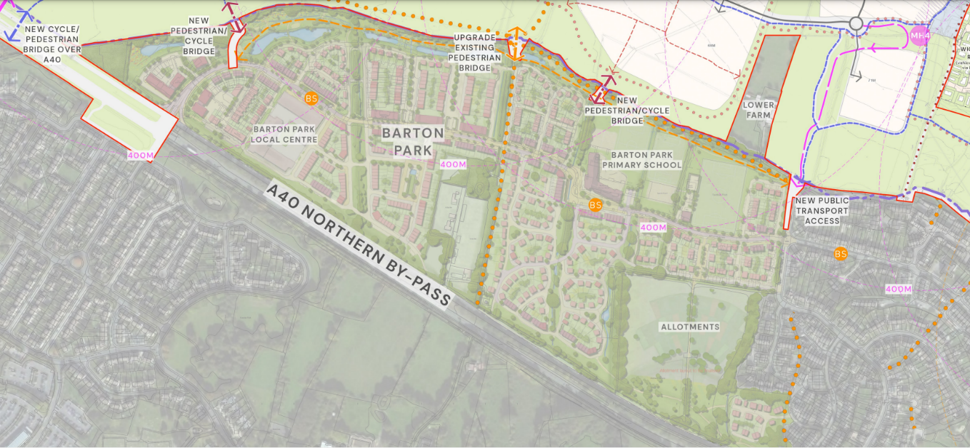

Community Employment Plan
- As detailed above, Redrow have had a significant change in personnel since the last shareholder meeting. This has led to some concern for the LLP about Redrow’s engagement with the Community Employment Plan. Significant elements of this (for example, local employment and apprenticeships) are obligations that the LLP can not deliver themselves. As a result, the housebuilders are under obligations for this through conditions in their purchase of the land. The LLP are establishing a new contact at Redrow and intend to formally meet with them on the expectations around their delivery against this. More formal steps will also be considered depending on the outcome of this meeting.
- Vistry have also got obligations for the Community Employment Plan but until they have a greater presence on site, they will not be able to meaningfully deliver against these. At this stage, we are confident that they are engaged in the process.
- The Community Employment Plan steering group meeting that the LLP run is to be held in the autumn and it is expected that progress will be reported at this.

Community and events
- BICEP meetings continue on a quarterly basis. At the most recent meeting, the primary school was represented and gave a positive report. They now have 150 pupils on their roll with the nursery and early years classes full. As well as the school being represented, BICEP members also had positive conversations and shared ideas about ways of signposting new residents in Barton to the Community Centre.
- The Leisure Team were represented and it seems some issues around the football pitches are reaching resolution. For example, a new approach to security and the lock will avoid unauthorised use.
- There are ongoing concerns about litter and estate maintenance which the LLP are liaising with First Port about. There was also a discussion about the installation of speed limit signs which we anticipate to be resolved by Oxfordshire County when the road is taken into their ownership through adoption over the next few months.

Publicity
- The Communications Team is preparing external communications around more than 50% of the scheme at Barton Park being high quality, tenure- blind affordable housing. This communications work has been scheduled for the middle of October.

Financial Implications
- There are no new financial implications arising directly from this report.

Legal Implications
- There are no legal implications arising directly from this report.

Report author | Sarah Knight
Job title | Head of Development
Service area or department | Housing Services
Telephone | 07483010867
e-mail | sknight@oxford.gov.uk

